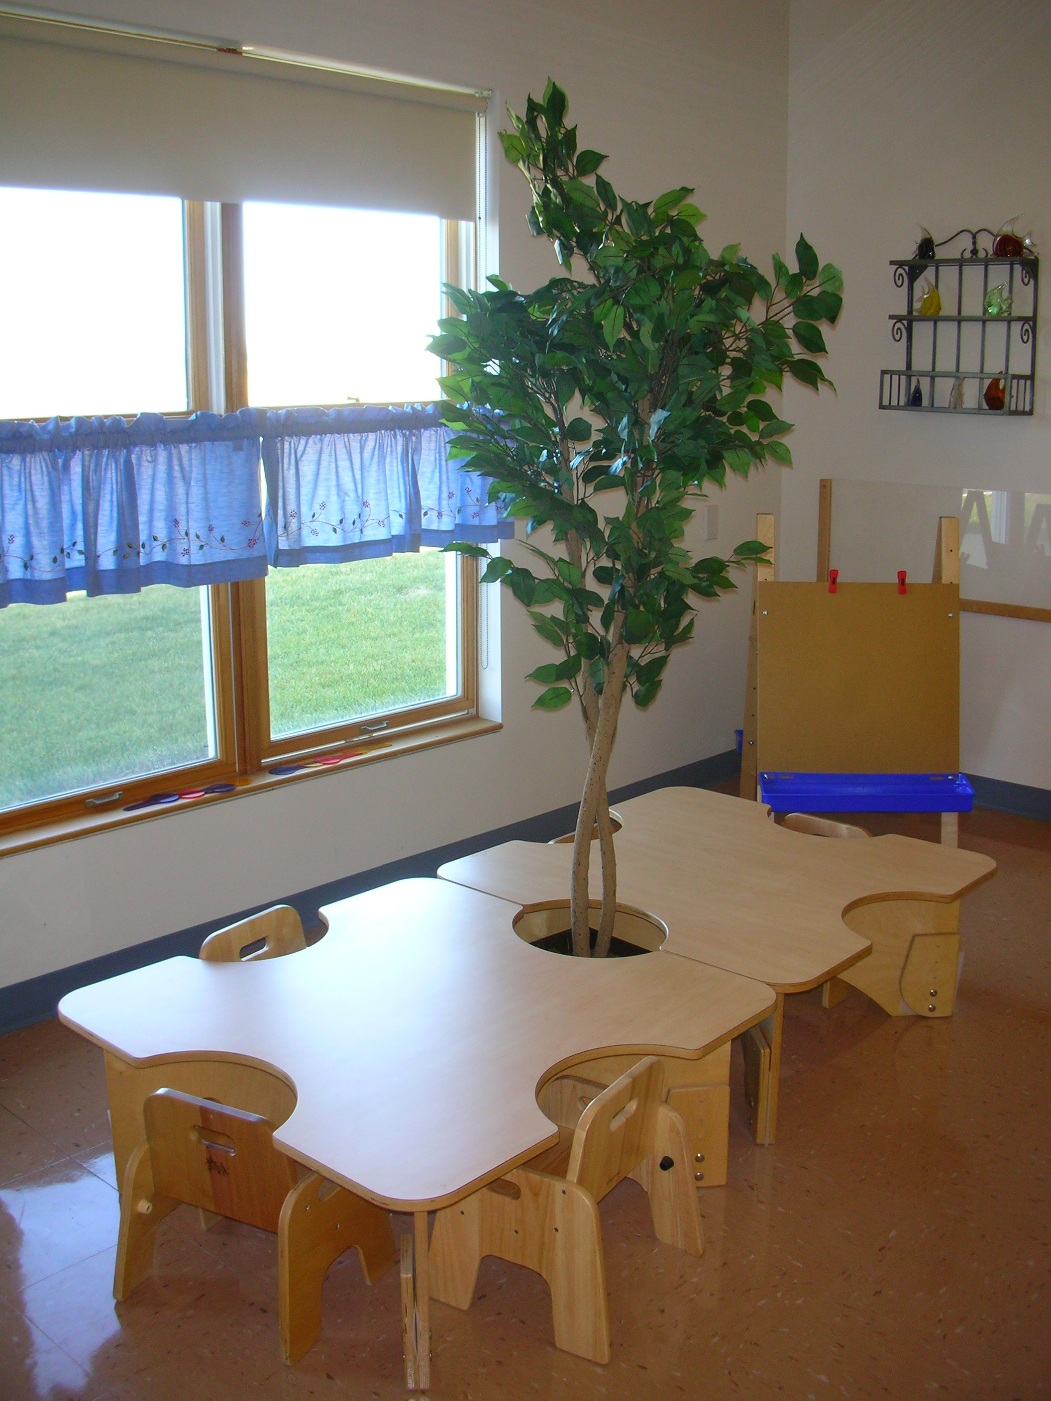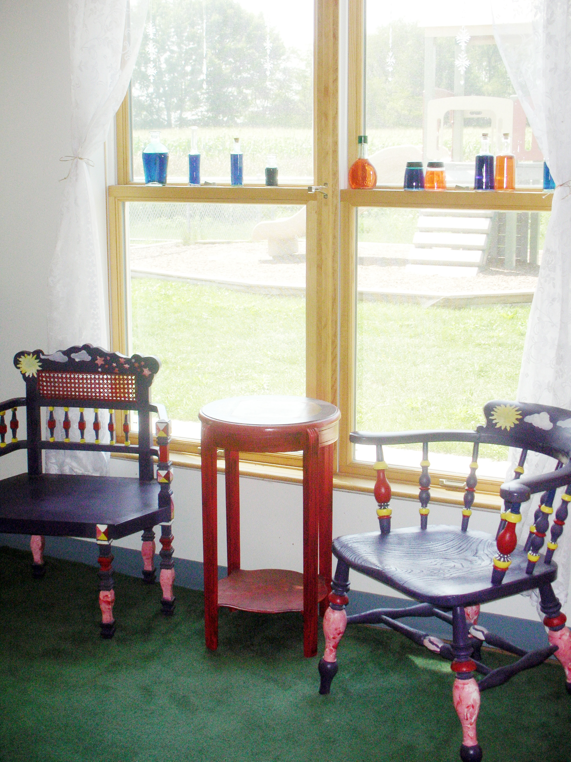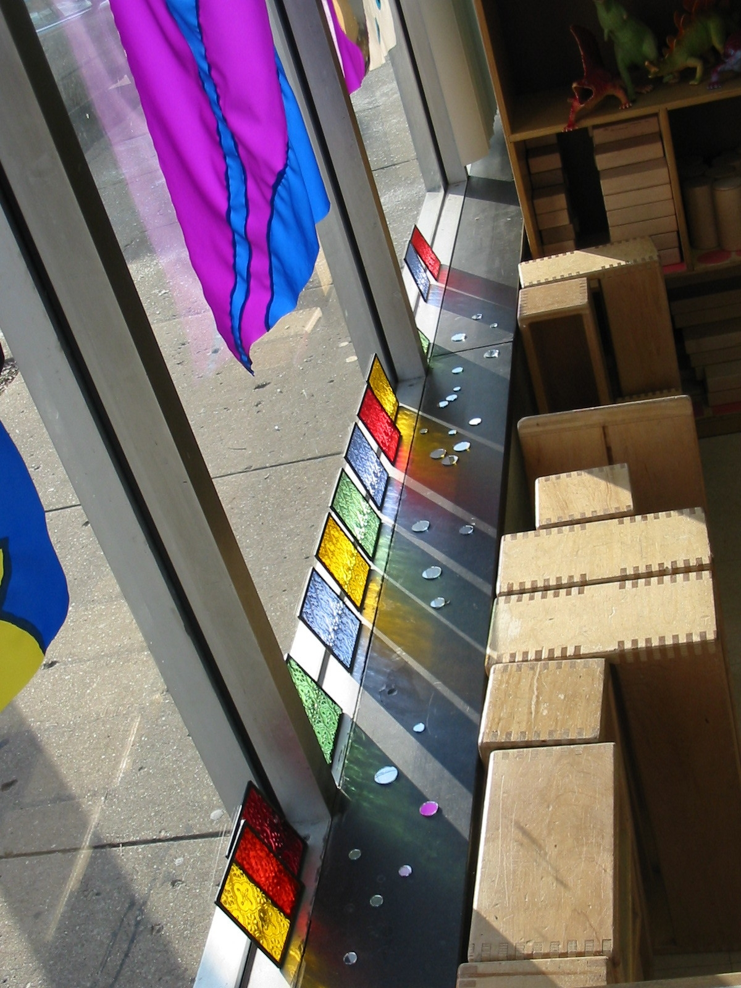
REVISITING THE ENVIRONMENT FOR YOUNG CHILDREN
A Two-day Seminar

In Reggio Emilia they believe children learn first from or with teachers, secondly
from and with other children, and thirdly from and with the environment, hence one
often hears the statement, the environment is the third teacher!

Chicago Commons, in collaboration with Columbia College Chicago and Crossroads for Learning, is offering a 2-day seminar Revisiting the Role of the Environment.
Presenters: Kristin Brizzolara-Educational Consultant, Kim Cothran-Chicago Commons and Karen Haigh-Columbia College Chicago

Dates and Time: June 22th and 23th, from 9:00AM – 4:00PM
Location: Columbia College Chicago/Hokin Hall, 623 S.Wabash, Chicago
Cost: $100 for both days, registration must be for both days. (Lunch Provided)
Registrations due by June17th.

* There are full scholarships for DFSS Head Start Program staff.

Focus areas may include the following:
• Levels, Boundaries, Room Arrangement, and Interest Areas
• Color, Light, Transparency, and Reflection
• Furniture and Interesting Objects
• Patterns, Textures, Materials, and Documentation
• Beauty, Nature, Identity, and Culture

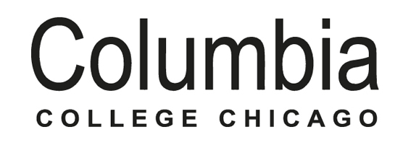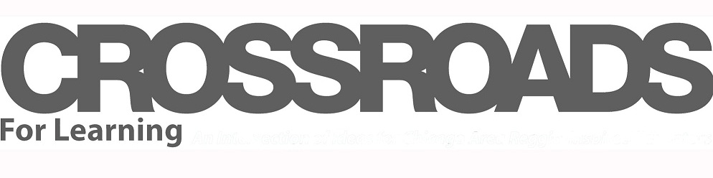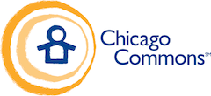

Revisiting the Environment for Young Children
Registration Form

Please note: The deadline for registration is JUNE 17TH, 2015.

Name: _____________________________________________________________________
(First and Last)

Position: ___________________________Organization: _____________________________

Work Address: ______________________________________________________________

Phone: _____________________________ E-mail: _________________________________
(Include summer e-mail address if off for the summer).

Below, in a couple of sentences, describe what you hope to gain from this experience.

_____ I am Early Head Start/Head Start staff and understand that I have a full scholarship for this seminar but know there will be a $25 fee if I do not attend after registering.  _____ I am a non-Head Start Staff person paying the fee of $100  Fax your registration to:  Attn: Nikki Perham  Fax: 773/826-4174  Can pay by check or credit card:  • Make Check for $100 Payable to:  Chicago Commons Child Development  Program.  Bring checks to 1st Day of Seminar at Columbia College Chicago/Hokin Hall, 623 S. Wabash, Chicago, IL | • To Pay by Credit Card or For More Information: Please contact Nikki Perham at 773.826.4178 or  parhamn@chicagocommons.org  PLEASE NOTE: We know many organizations, need fund requests approved and POs submitted, so If you need more time (beyond June 17th) to process payment but plan to attend the seminar, contact Nikki Perham at  at 773.826.4178 or  parhamn@chicagocommons.org  to reserve a space and let her know when payment will be made.  Apply early as space may become limited-Registrations by first-come first-serve basis  Not responsible for changes in presenters due to unforeseen circumstances.

