U.S. STUDY GROUP
REGGIO EMILIA, ITALY

Organized by International Study Tours, LLC
in collaboration with Reggio Children
November 4 - 11, 2017

WORLD RENOWNED SCHOOLS The experience of the municipal infant toddler centers and preschools of Reggio Emilia is the subject of interest, research and exchange on the part of students, teachers, teacher educators, researchers, administrators, and political and cultural figures from Italy and throughout the world. The context of this community and its history are highly regarded, rooted in choices made following WWII, pedagogical but also political, cultural and ethical choices which would support a new democratic society.

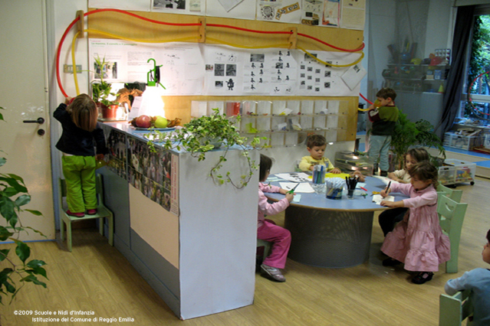

Opportunities for dialogue and exchange with educators in Reggio Emilia will offer participants many possibilities to gain a deeper understanding of the history, challenges, strategies and accomplishments of the Municipal Infant Toddler Centers and Preschools of Reggio Emilia.

STUDY GROUP PROGRAM WILL INCLUDE:
- Background on the pedagogical, historical, cultural and social aspects of the Reggio Emilia Approach to education
- Visits to Preschools and Infant Toddler Centers
- Presentations by pedagogistas, atelieristas and teachers on the principles of the Educational Project and essential elements in the daily life of the preschools and infant toddler centers
- Concurrent sessions with presentation and analysis of research projects realized inside the Preschools and Infant Toddler Centers
- Discussion and exchange of experiences among participants relevant to their own practice and context in the U.S.
- Time at the Loris Malaguzzi International Center to see current exhibitions, the Ateliers, and the Documentation and Educational Research Center
- Walking tour of the town and opportunities to encounter the community

INTERNATIONAL MEETING PLACE The venue is the Loris Malaguzzi International Center, which opened in February 2006 and now encompasses an International Preschool and Primary School, a book shop and Pause Restaurant. As described by Carlina Rinaldi, President of Reggio Children Foundation- Loris Malaguzzi Center . . . "It was created to give greater value to a strong and distinctive characteristic of Reggio Emilia; the ability to lend listening, visibility and support to the rights and requests of children, young people, families and teachers. The Center is a dedicated meeting place where professional development and research intersect for people in Reggio Emilia, Italy and the world who wish to innovate education and culture. “

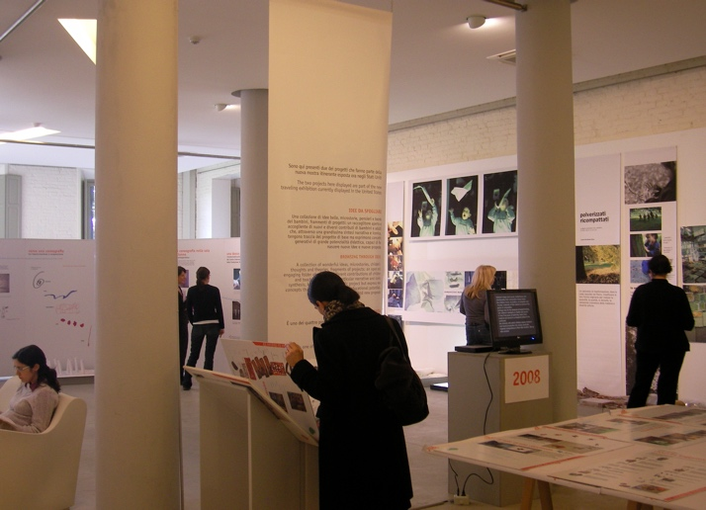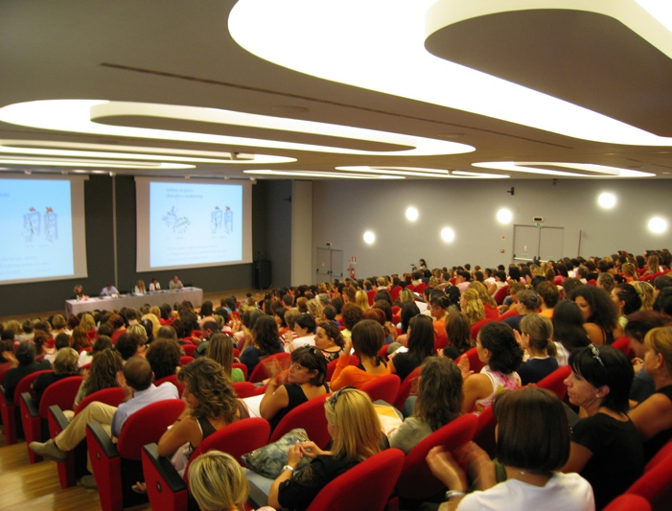

COST: $2,450 or $2,650 per person (based on shared accommodations)
The cost includes the program fee to Reggio Children, hotel accommodations for 7 nights, services provided by Angela Ferrario, U.S. Liaison for Study Groups to Reggio Emilia and by International Study Tours, LLC.
The per person amount is based on hotel accommodations in shared double rooms at 3 or 4 star hotels. Single room supplement is $300 (see registration form). North American Reggio Emilia Alliance (NAREA) members receive a $100 discount. For membership information please visit: www.reggioalliance.org.

Fee to Reggio Children S.r.l.:
- The organization and presentation of the study group program for the week
- An informational folder for each participant with materials about the town of Reggio Emilia, its municipal infant toddler centers and preschools, Reggio Children and the Loris Malaguzzi International Center
- Private bus transportation to and from the centers in Reggio Emilia when required by the program
- Professional interpreters when required by the program
- Insurance as specified in Responsibility clause below
- Refreshments during coffee breaks each day
- Lunch Mon through Friday at Pause Restaurant and a farewell reception
Services provided by Angela Ferrario, U.S. Liaison for Study Groups to Reggio Emilia and by International Study Tours, LLC:
- Introductory meeting and welcome lunch on Sunday, November 5, 2017
- Arrangement of hotel accommodations for 7 nights (buffet style breakfast is included daily at all hotels)
- Registration process and coordination of the study group experience to support professional development, collaboration and collegiality among participants
- Communication with Reggio Children and group participants prior to departure and while in Reggio Emilia
- Credit card services, foreign currency transfer fees and administrative services
- Assistance arranging private ground transportation between airports and Reggio Emilia

HOTEL ACCOMMODATIONS
Accommodations for 7 nights are included from check-in on Saturday, November 4 to check-out on Saturday, November 11. To accommodate our group, blocks of rooms have been reserved at Albergo Morandi http://www.albergomorandi.com and Hotel Europa http://www.hoteleuropa.re.it/en/, both within 10 to 20-minute walking distance of the Loris Malaguzzi International Center. Rates for accompanying non-participants and for additional nights are available upon request. Every effort will be made to honor hotel preferences while the priority is to keep groups from the same school/organization together.

REGISTRATION & PAYMENT
A $500 deposit is required to reserve a space. Please mail check deposit made payable to International Study Tours, LLC and Registration Form on page 4 to: Angela Ferrario, 15 Beach Street Extension, Milford, MA 01757. Confirmation and Invoice for Balance Due will be sent by email. Balance is due upon receipt of invoice but no later than October 1, 2017 and may be made by check or credit card (Visa or MasterCard).

REFUNDS & CANCELLATION
All monies are refundable in full minus a $100 processing fee until October 1, 2017. For cancellations received after October 1, 2017, no refund will be due.

TRAVEL AGREEMENT
Please sign and submit the Travel Agreement found on page 5, along with your Registration Form and deposit.

ARRIVAL & DEPARTURE
Participants are responsible for booking their own flights. Airfare is not included. Bologna Marconi is the most convenient airport to reach Reggio Emilia. Alternatively, you could fly to Milan Malpensa or Milan Linate. Participants should arrange to fly on Friday, November 3, arriving in Reggio Emilia on Saturday, November 4 (departure from the U.S. is one day prior to arrival in Italy). Our first group gathering in Reggio Emilia is the introductory meeting and welcome lunch on Sunday, November 5 at 12 noon. The Program begins Monday morning and ends on Friday, November 10 at approximately 6:30 p.m. Hotel check-out is Saturday, November 11 by 11 a.m.

Please Note: It is recommended to be at the airport at least 2 hours before your scheduled flight departure time. If driving from Reggio Emilia, it takes approximately 45 mins. to reach Bologna Airport and 2 ½ hours to reach Milan Malpensa or Linate Airports depending on traffic conditions. Allow more time if traveling from/to either airport by public transportation and check train schedules in advance.

AIRPORT PICK UP SERVICE
Assistance with making private ground transportation arrangements between the airport and Reggio Emilia for individuals or for groups traveling together is available upon request. Cost is additional.

PHOTOGRAPY & VIDEOTAPE POLICY
For privacy issues, participants are not allowed to photograph or videotape inside the infant-toddler centers and preschools, inside the Exhibition area and the Ateliers at the Loris Malaguzzi International Center, as well as during the presentations. Reggio Children’s policy allows the possibility to audio record the presentations.

For further information, contact:
Angela Ferrario, U.S. Liaison for Study Groups to Reggio Emilia
International Study Tours, LLC, Milford, MA
Phone: 508 473 8001
Email: aferrario@comcast.net
Reggio Emilia, Italy
US STUDY GROUP
November 4 - 11, 2017
REGISTRATION FORM

NAME ______________________________________________________________________________

WORK ADDRESS ____________________________________________________________________

CITY/TOWN ________________________________STATE _______________ ZIP CODE __________

PHONE NUMBER______________________ E-MAIL ________________________________________
(Please provide an email address that you check regularly as it will be used for correspondence.)

NAME OF SCHOOL/ORGANIZATION: ____________________________________________________

JOB TITLE __________________________________________________________________________

Please check yes or no:
I consent to have my professional bio shared with the group in a compiled document. Yes [ ] No [ ]
I consent to have my email address shared with the group in a participant list. Yes [ ] No [ ]
I am a member of the North American Reggio Emilia Alliance (NAREA). Yes [ ] No [ ]

Cost
Per person cost includes double or single accommodations at three-star Albergo Morandi http://www.albergomorandi.com or four-star Hotel Europa http://www.hoteleuropa.re.it/en/, for 7 nights from check-in on Saturday, November 4 to check-out on Saturday, November 11.
NAREA members receive a $100 discount. If you are a NAREA member check yes above and $100 will be deducted from your invoice. For membership information please visit: www.reggioalliance.org.

Please check one:
[ ] $2,650 Shared Double Room four-star hotel (cost per person)
[ ] $2,450 Shared Double Room three-star hotel (cost per person)
[ ] $2,950 Single Room four-star hotel
[ ] $2,750 Single Room three-star hotel

Please Check One:
[ ] I have a roommate. My roommate’s name is: _____________________________________________
[ ] Please find me a roommate, if possible.

Any special dietary limitations? (please describe, if applicable): _____________________________

____________________________________________________________________________________

To reserve a space, submission of Registration Form and $500 deposit per person is required along with a signed Travel Agreement found on page 5.
Please mail Registration Form, Travel Agreement and $500 check made payable to International Study Tours, LLC to:
Angela Ferrario
15 Beach Street Extension
Milford, MA 01757

U.S. STUDY GROUP
in
REGGIO EMILIA, ITALY

Organized by International Study Tours, LLC
in collaboration with Reggio Children
November 4 - 11, 2017

Travel Agreement

I agree that International Study Tours, LLC acts only as the agent for the several hotels and other suppliers providing accommodations and services to participants.
I agree that International Study Tours, LLC shall not be liable for any cancellation, injury, loss, damage, expense, delay or inconvenience which may be caused or sustained by any participant.
I understand that participants are responsible for individual insurance for accidents of any type that may occur during the program and that travel Insurance is not included and should be secured by the individual participant.

Participant Signature: ________________________________Date: ____________

